AP Econ
Student Name
Institution Affiliation

AP Econ
Base your answers to these questions on your understandings from Ragan chapters 13, 14 and 16, but you may also support your work with more research if you feel it is warranted. Answer all questions relating to Maggie’s Pizzeria.
- Assume that the standard price of a pizza is $15 and the rental rate for a pizza oven is $150 per unit. Refer to the table below to answer the following questions:
Quantity of Capital (Ovens) Quantity of Output (Pizzas)
0 0
1 30
2 55
3 70
4 78
5 85
6 89
What is the MRP of the second unit of capital (ovens)? Show your reasoning and explain any assumptions you are making (2 pts.) Will the pizzeria employ a second oven? Explain why or why not. (2 pts) How many ovens will the pizzeria utilize? Explain fully. (2 pts)
MRP = Change in TR/change in unit of capital
= (825-450)/(2-1) = 375
Total Revenue (TR) = Output * Price.
The assumption is that change in output due to increase in unit of capital will not affect the market price for Pizza.
The Pizzeria will not employ a second Oven since MRP assumes that the expenditure on other factors remain unchanged.
The pizzeria will only use two ovens. At this level of production, an output of 55 units requires the use of only two ovens. Production of any additional unit will call for additional oven.
- Maggie’s Pizzeria operates and rents in a rural area in Alberta. Draw a correctly-labelled graph to illustrate the land market in this area where land is in fixed supply. Be sure to label the axes, the supply and demand curves for land, the equilibrium rental rate and amount of land used. (2 pts) Shade in and label the area that represents economic rent. (1 pt.) Explain why you have shaded in this area and what the concept represents. (2 pts)

Rent per acre
Supply curve

R_{e}

Demand Curve
L_{e}
Economic rent Land (Acres)

Where R_{e} is the equilibrium Rental Rate and L_{e} is the Land used at R_{e}.
The supply of land is perfectly inelastic. Therefore, the value of the land is determined by the amount the highest bidder is willing to pay. Therefore, the shaded part depicts the income received by Land over and above the amount required to induce a given quantity of the factor to be supplied. The economic rent section depicts that all earnings are rent.
- Maggie’s Pizzeria hires delivery drivers from a perfectly-competitive labour market. Draw correctly-labelled, side-by-side graphs of delivery-driver supply and demand for Maggie’s Pizzeria and for the entire driver market. (4 pts) On your graphs, show how an increase in the supply of drivers would affect the equilibrium wage and the number of drivers hired, both by Maggie’s Pizzeria and in the delivery market as a whole. (2 pts) Now, using a separate colour on your graphs, or with a new pair of graphs, illustrate how a decrease in the demand for pizza would affect the equilibrium wage and the number of drivers hired, both by Maggie’s Pizzeria and in the delivery market as a whole. (2 pts) Be sure to explain your reasoning on the graphs as a part of your solution.

Entire Driver Market Maggie’s Pizzeria Only
Wage Wage
Supply
S1 W1
W W Supply
W1
W2 Demand D = MRP

Q2 Q Q1 Quantity (L) Q2 Q1 Q Quantity (L)
Considering an in supply of drivers would increase the number of drivers hired (from Q to Q1) and reduce the wage rate (From W to W1) in the driver’s market. The effect on Maggie’s Pizzeria would be increase in wage from W to W1 and reduce in number of drives hired from Q to Q1.
Decrease in demand for Pizza would decrease the wage rate from W to W2 and the number of drivers hired from Q to Q2 in the driver’s market. The effect on Maggie’s pizzeria would be constant wage rate and decrease in number of drivers hired from Q to Q2.
- Maggie’s Pizzeria is the only pizza restaurant in their area of Alberta, and therefore the only employer of pizza chefs. Draw a correctly-labelled graph for the market for pizza chefs in this region. Be sure to label the axes, the curves, the wage rate and amount of cooks used. (4 pts) Illustrate and explain any inefficiency in this market. What might be done to eliminate or reduce any inefficiency? (2 pts)
Wage

W

MRPL=DL VMPL
Quantity of Labor
The market suffers from allocation inefficiency. Maggie will always be want to produce less and sell at higher prices to maximize profit hence setting lower wage rates. As a monopoly, she would not be ready to produce enough output to be allocatively efficient. To correct this, she needs to produce at a point Q_{e} where the price is equal to the Marginal Cost.
- Maggie’s Pizzeria delivers its pizzas in non-reusable, non-recyclable thermal plastic containers. Draw a correctly-labelled graph showing the market for these pizza containers. (2 pts) On the same graph, show the socially-optimal level of container production, and explain any differences. (2 pts) What could the government do, economically, to achieve this socially-optimal level of production? (1 pts) A suggestion has been made to ban completely these thermal pizza containers. What are the problems with such an action? (1 pts)
Price of Containers
MSC
Supply
P_{soc}

Demand (MPB = MSB)

Q_{soc} Quantity
The output reflects all the costs and benefits of production of the Pizza containers. With reflection of the effects of externalities, this could be the equilibrium of the Pizza containers.
Negative externalities results to social costs being greater than the private cost hence making market output to be in-efficient and might lead to overproduction of a good. The government can use taxes to make firms not to produce goods generating negative externalities. Taxes will increase private cost hence making producers to change to socially-optimum level (Ragan & Lipsey, 2014).
Ban of thermal pizza containers would also affect the pizza market since the cost of the new means of packaging and transportation would be added to the price of Pizzas.
________________________________________________________________________
Additional Questions:

- Describe the characteristics of a natural monopoly.
- Fixed costs are usually very large as compared to the variable costs. Large fixed costs usually result to very large average costs even at small amounts of production. As output increases, these average costs falls.
- Average costs usually exceed marginal costs over a great rage of output. These average costs proceeds falling over the relevant range of output.
- As compared to having several competing firms, one firm in the case of natural monopoly can produce a given quantity of output at lower average costs.
- Describe marginal cost pricing as a means of regulating the price of a natural monopoly.
Marginal costs pricing helps to sets price equal to marginal costs. As a result, there will be efficient use of resources. However, the monopoly in this case is likely to incur an economic loss. The long run effects that can be experience due to the use of marginal costs pricing rule is negative effect on profit (Ragan & Lipsey, 2014).
- Describe what is meant by a Nash equilibrium in game theory.
Nash equilibrium refers to the point at which the optimal outcome of a game is achieved if there is no way of deviation from the initial strategy. No player in this case can deviate from the initial chosen strategy even after making consideration of the opponent’s choice. Generally, no player can receive incremental benefit through changing actions (Ragan & Lipsey, 2014).
- With a diagram, explain the differences in long-run equilibrium between a perfect competitor and a monopolistically competitive firm.

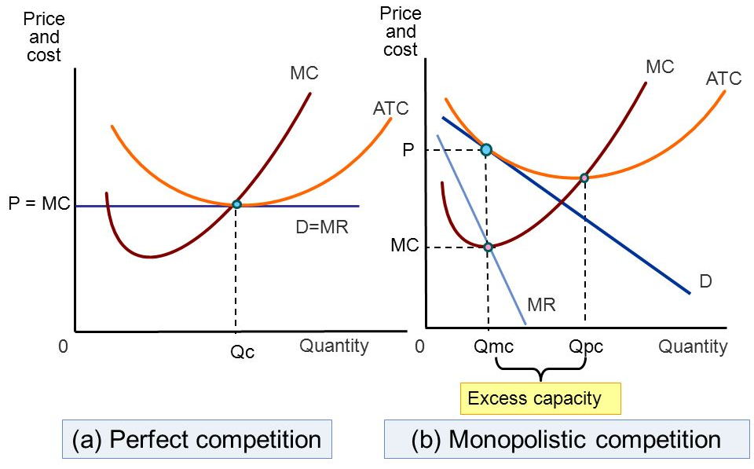
In the long run, any firm in a monopolistic competitive market will produce the amount of goods and services where the long run marginal cost (MC) precisely intersects marginal Revenue curve. The price in this case is set where the quantity produced falls on the Demand curve as shown above. There will always be an excess capacity. For a perfect competitive market, firms will produce well where MC =- MR. The price will also be at the same point where P = MC hence P = MC = MR in perfect competition (Ragan & Lipsey, 2014).

Reference
Ragan, C. T. S., & Lipsey, R. G. (2014). Economics (14th Canadian edition).

